ParkIt (car park availability app)

Functional Requirements

1. Login Page  
   1.1 The system must authenticate users before allowing them to log in  
   1.2 The system must allow for users to sign up for an account if they do not have one.  
    1.2.1 The system must request for users’ username, password and phone number  
    1.2.1.1 The system must issue and authenticate a verification code sent to the phone number  
   1.3 The system must allow for users to reset their account passwords through a ‘forgot password’ button  
    1.3.1 The system must be able to send a link to the user to a site to allow them to   
    Reset their password

1.3.1.1 The system must be require the user to type in the new password twice to ensure the accuracy of password

1. Home Page  
   2.1 The system shall display user’s current location  
   2.2 The system must allow users to search for a location

2.3 The system shall display user’s search history

2.3.1 The system must allow users to clear user search history

2.4 The system must be able to display a map view of the user's current location and the surrounding area.

2.5 The system must be able to highlight the locations of nearby car parks on the map, with a visual indicator of their availability.

1. Car Park Comparison Page  
   3.1 The system must be able to list out all car parks within a certain range of the selected location  
    3.1.1 The system must be able to sort car parks by distance from location  
    3.1.2 The system must be able to display the parking rates of car parks

3.1.3 The system must be able to sort car parks by slot availability  
3.2 The system must be able to display overall recommendations of two call parks

1. Navigation Page  
   4.1 The system must be able to show the available routes from the user’s current location to the selected car park

Non-Functional Requirements

1. Usability  
   1.1 The system shall be available in multiple languages to allow for users to have the same experience regardless of the language being used by the user.  
   1.2 The system shall have visible buttons

1.3 the app must have help and support features

1.3.1 The system must have in-app tutorials

1.3.2 The system must have user guides

1.3.3 The system must have a support centre

1. Performance  
   2.1 The system must be able to respond to actions within 1s  
   2.2 The system must be able to support up to 10,000 users simultaneously
2. Reliability  
   3.1 The system shall obtain the data from official data collection/carpark websites

3.2 The system must use APIs from reliable resources as Google Map

3.3 The system must recover from any failures or errors within a 3 minutes

3.4 The system must provide accurate information on car park availability,

3.4.1 The system must provide accurate number of available spaces in real-time

3.4.2 The system must provide accurate prices of slots in real-time

1. Supportability   
   4.1 Detailed documentation of the app and its systems must be available and regularly updated

4.2 The system must have robust monitoring and logging systems in place, which would provide visibility into the performance and behaviour of the app

4.3 The system must have a system for reporting and tracking errors and failures,

4.4 The system must have a mechanism for users to report issues and provide feedback

Data Dictionary

| Term | Definition |
| --- | --- |
| Route | A path the user can take to get from point A to point B |
| Car park rates | Fees per hour for parked vehicles |
| Car park | an area or building where cars or other vehicles may be left temporarily. |
| Vehicle | a thing used for transporting people or goods, especially on land, such as a car,motorbike, or electric vehicle |
| Carpark slots | Available spots that a vehicle could be parked at |
| Time | a point of time as measured in hours and minutes past midnight or noon |

Initial Use Case Model

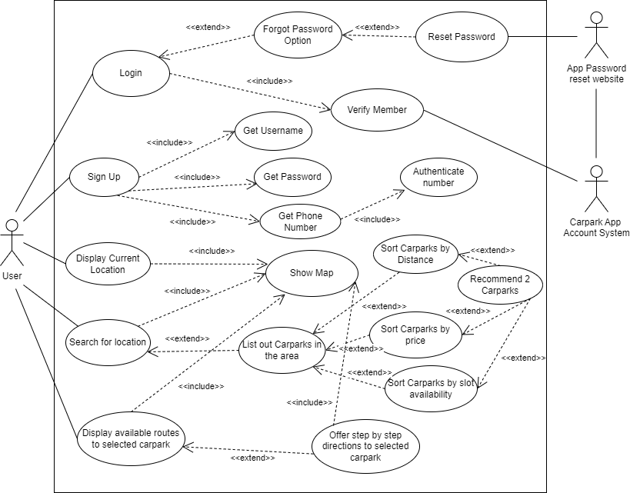

Use Case Descriptions

* CPK.001: Sign up
* CPK.002: Login
* CPK.003: Display current location
* CPK.004: Search for location
* CPK.005: Listing of car parks
* CPK.006: Sorting of list
* CPK.007: Display available routes

| Use Case ID: | CPK.001 | | |
| --- | --- | --- | --- |
| Use Case Name: | Sign up | | |
| Created By: |  | Last Updated By: |  |
| Date Created: | 09/02/2023 | Date Last Updated: | 09/02/2023 |

| Actor: | App User (Initiating actor), App Account System |
| --- | --- |
| Description: | User signs up for an account |
| Preconditions: | 1. User has a phone number 2. User does not have an account |
| Postconditions: | 1. User creates an account |
| Priority: | Essential |
| Frequency of Use: | Only once in app lifetime |
| Flow of Events: | 1. User will click on Account Sign up option 2. User will be brought to the Sign up page 3. User will be prompted to enter a username, password and phone number 4. A verification code will be sent to the user’s phone number 5. User will enter the verification code and verify their details 6. User’s account is created and logged in the App Account System |
| Alternative Flows: |  |
| Exceptions: | EX1: If phone number cannot be verified   1. App does not allow for account to be created |
| Includes: |  |
| Special Requirements: | 1. App must respond to user’s actions within 1s 2. App Account System must store up to thousands of users account data 3. App must have multiple supported languages 4. App must recover from errors within 3 minutes |
| Assumptions: |  |
| Notes and Issues: |  |

| Use Case ID: | CPK.002 | | |
| --- | --- | --- | --- |
| Use Case Name: | Login | | |
| Created By: |  | Last Updated By: |  |
| Date Created: | 09/02/2023 | Date Last Updated: | 09/02/2023 |

| Actor: | App user (Initiating actor), App Account System, App Password  Reset Site |
| --- | --- |
| Description: | App user logs in to their account or resets their password |
| Preconditions: | 1. App user has an account 2. App user has the phone number used to create their account |
| Postconditions: | 1. App user logs in to their account |
| Priority: | Essential |
| Frequency of Use: | Low, only log in once, will remain logged in unless user chooses to  log out |
| Flow of Events: | 1. User chooses the login option 2. User enters their username and password in the login page 3. App verifies the account login information with the App Account System 4. If account information is verified, user is logged in to the app |
| Alternative Flows: | AF Step 2: If user forgets their account password   1. User chooses the forget password option 2. User is brought to the app account password reset site 3. A verification code is sent to the user’s registered number 4. User enters verification code 5. If successful, user is prompted to enter a new password 6. The password is updated and the account login information is updated in the App Account System 7. User returns to login page 8. Returns to step 2 |
| Exceptions: | EX1: If user enters the wrong verification code   1. App does not allow for user to reset their password |
| Includes: |  |
| Special Requirements: | 1. App must respond to user’s actions within 1s 2. App Account System must store up to thousands of users account data 3. App must have multiple supported languages 4. App must recover from errors within 3 minutes |
| Assumptions: |  |
| Notes and Issues: |  |

| Use Case ID: | CPK.003 | | |
| --- | --- | --- | --- |
| Use Case Name: | Display current location | | |
| Created By: |  | Last Updated By: |  |
| Date Created: | 09/02/2023 | Date Last Updated: | 09/02/2023 |

| Actor: | App User (Initiating actor) |
| --- | --- |
| Description: | App displays current location of user |
| Preconditions: | 1. User has an app account 2. User is logged in 3. User has a GPS-enabled device |
| Postconditions: | 1. Current location of driver is shown |
| Priority: | Essential |
| Frequency of Use: | Conditional, only when user launches app with GPS on |
| Flow of Events: | 1. User click on display current location option 2. App will receive user’s GPS information 3. App display user’s current location |
| Alternative Flows: |  |
| Exceptions: | EX1: User does not have GPS turned on   1. App displays message “User location is not available” |
| Includes: | 1. Login |
| Special Requirements: | 1. App must respond to user’s actions within 1s 2. App must have multiple supported languages 3. App must recover from errors within 3 minutes 4. App must use a reliable API to ensure accurate data 5. App must have a error logging and feedback feature 6. App must support up to 10000 users concurrently 7. App must have an in-app tutorial page |
| Assumptions: | 1. GPS data is accurate |
| Notes and Issues: |  |

| Use Case ID: | CPK.004 | | |
| --- | --- | --- | --- |
| Use Case Name: | Search for location | | |
| Created By: |  | Last Updated By: |  |
| Date Created: | 09/02/2023 | Date Last Updated: | 09/02/2023 |

| Actor: | App User (Initiating actor) |
| --- | --- |
| Description: | User searches for a location and app displays all carparks within  range on the map |
| Preconditions: | 1. User has an account 2. User is logged in to their account |
| Postconditions: | 1. App displays all carparks within range on the map |
| Priority: | Essential |
| Frequency of Use: | High, 1-5 times a day |
| Flow of Events: | 1. User chooses location search option 2. User searches for a location by entering name OR postal code 3. App displays all carparks within a certain distance range on the map along with their hourly rates, distance from specified location and number of slots available |
| Alternative Flows: |  |
| Exceptions: | EX1: If there are no carparks within distance range   1. App displays the message “No carparks within range of specified location!” 2. App returns to location search page |
| Includes: | 1. Login |
| Special Requirements: | 1. App must respond to user’s actions within 1s 2. App must have multiple supported languages 3. App must recover from errors within 3 minutes 4. App must use a reliable API to ensure accurate data 5. App must have a error logging and feedback feature 6. App must support up to 10000 users concurrently 7. App must have an in-app tutorial page |
| Assumptions: | 1. Carpark information is accurate |
| Notes and Issues: | 1. Even if the APIs used are reliable, there can still be times when they go down and this will affect the app usage 2. The initial range to determine which carparks show up on the map is still to be determined |

| Use Case ID: | CPK.005 | | |
| --- | --- | --- | --- |
| Use Case Name: | Listing of Car Parks | | |
| Created By: |  | Last Updated By: |  |
| Date Created: | 09/02/2023 | Date Last Updated: | 09/02/2023 |

| Actor: | App user (Initiating actor) |
| --- | --- |
| Description: | All carparks within range of specified location are displayed in a list |
| Preconditions: | 1. User has an account 2. User is logged in 3. User has searched for a specific location |
| Postconditions: | 1. All carparks within range are displayed in a list along with their hourly rate, distance from specified location and slots available |
| Priority: | Essential |
| Frequency of Use: | High, 1-5 times a day |
| Flow of Events: | 1. User chooses option to list all carparks within range 2. All carparks within range are displayed along with their hourly rates, distance from specified location and number of slots available |
| Alternative Flows: |  |
| Exceptions: |  |
| Includes: | 1. Login 2. Search for location |
| Special Requirements: | 1. App must respond to user’s actions within 1s 2. App must have multiple supported languages 3. App must recover from errors within 3 minutes 4. App must use a reliable API to ensure accurate data 5. App must have a error logging and feedback feature 6. App must support up to 10000 users concurrently 7. App must have an in-app tutorial page |
| Assumptions: | 1. Carpark information is accurate |
| Notes and Issues: | 1. Even if the APIs used are reliable, there can still be times when they go down and this will affect the app usage 2. The initial range to determine which carparks show up on the map is still to be determined |

| Use Case ID: | CPK.006 | | |
| --- | --- | --- | --- |
| Use Case Name: | Sorting of list | | |
| Created By: |  | Last Updated By: |  |
| Date Created: | 09/02/2023 | Date Last Updated: | 09/02/2023 |

| Actor: | App User (Initiating actor) |
| --- | --- |
| Description: | Sorts list of carparks by the selected user preference |
| Preconditions: | 1. User has an account 2. User is logged in to their account 3. User has searched for a specific location 4. User has chosen to view all carparks within range in a list |
| Postconditions: | 1. The list of carparks is sorted according to the user’s selected preference |
| Priority: | Essential |
| Frequency of Use: | High, 1-5 times a day |
| Flow of Events: | 1. User selects their preference for sorting, either by distance from specified location, by pricing or by number of slots available 2. App sorts and displays the list of carparks according to the selected user preference 3. App also recommends 2 carparks for user’s selection based on the user’s preference |
| Alternative Flows: |  |
| Exceptions: |  |
| Includes: | 1. Login 2. Search for location 3. Listing of Carparks |
| Special Requirements: | 1. App must respond to user’s actions within 1s 2. App must have multiple supported languages 3. App must recover from errors within 3 minutes 4. App must use a reliable API to ensure accurate data 5. App must have a error logging and feedback feature 6. App must support up to 10000 users concurrently 7. App must have an in-app tutorial page |
| Assumptions: | 1. Carpark information is accurate |
| Notes and Issues: | 1. Even if the APIs used are reliable, there can still be times when they go down and this will affect the app usage 2. The initial range to determine which carparks show up on the map is still to be determined |

| Use Case ID: | CPK.007 | | |
| --- | --- | --- | --- |
| Use Case Name: | Display available routes | | |
| Created By: |  | Last Updated By: |  |
| Date Created: | 09/02/2023 | Date Last Updated: | 09/02/2023 |

| Actor: | App User (Initiating actor) |
| --- | --- |
| Description: | App displays route to carparks |
| Preconditions: | 1. User has an account 2. User is logged into their account 3. User has searched for a specific location 4. User has chosen to view all carparks within range in a list 5. User has sorted carpark list by their preference |
| Postconditions: | 1. App displays step by step direction to selected carpark |
| Priority: | Essential |
| Frequency of Use: | High, 1-5 times a day |
| Flow of Events: | 1. User chooses 1 of the 2 recommended carparks based on their preference 2. User click on Display available routes 3. App receives User’s GPS information 4. App receives data on selected carpark’s GPS location 5. App displays all routes from User’s current location to selected carpark 6. User chooses a route and app offers step by step direction to selected carpark |
| Alternative Flows: | AF Step 1: If user does not want to choose any of the 2 recommended  carparks OR If user already has a specific carpark in mind   1. User chooses the “back” option to return to the list of sorted carparks according to their preference 2. User chooses another carpark from the list 3. Return to step 2   AF Step 3: If user does not have GPS enabled   1. User enters their current location manually 2. Skips to step 5 |
| Exceptions: |  |
| Includes: | 1. Login 2. Search for location 3. Listing of Carparks 4. Sorting of list |
| Special Requirements: | 1. App must respond to user’s actions within 1s 2. App must have multiple supported languages 3. App must recover from errors within 3 minutes 4. App must use a reliable API to ensure accurate data 5. App must have a error logging and feedback feature 6. App must support up to 10000 users concurrently 7. App must have an in-app tutorial page |
| Assumptions: | 1. GPS data is accurate 2. Carpark information is accurate |
| Notes and Issues: | 1. Even if the APIs used are reliable, there can still be times when they go down and this will affect the app usage 2. The initial range to determine which carparks show up on the map is still to be determined 3. The slot availability of carparks might change as the user is navigating to the selected carpark |